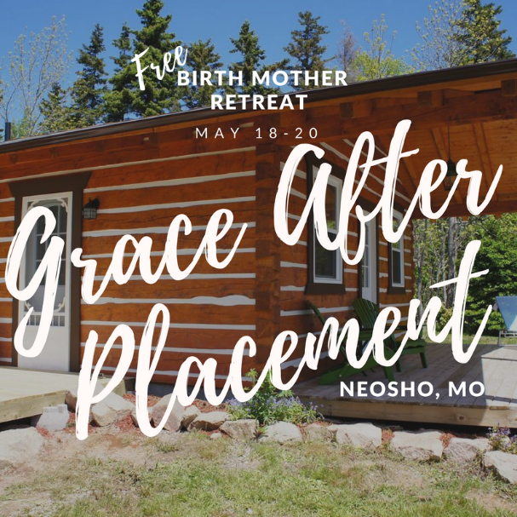

Friday May 18- Sunday May 20
Harrison Creek Retreat 10613 Poppy Dr. Neosho, MO 64850
No cost for birth mothers
Maybe you’ve never heard of a birthmother retreat or maybe you’ve already attended one! Either way, we are excited to meet you! No matter which type of adoption you chose, you have made a selfless decision. Emotions vary after placement and may include feelings of deep sadness, confusion and long-term grieving. No one can define your journey for you. We can only share our experiences and invite grace into our lives to reflect, to heal and to find meaning in our stories.
This birth mom retreat will be a safe place to bring your heart and connect with others who truly understand. We have a great weekend planned with both meaningful and fun activities!
We are excited about our Friday night paint class, Saturday morning Yoga, and a Saturday afternoon rafting trip down a very calm river. Saturday night will be a time of meaningful connection and sharing stories for those who are ready to do that.
Adoption is a life-long decision deserving life-long support. We hope this retreat helps you build a network of friends that will help you on your post-placement journey. We are looking forward to meeting you!
To Register or Receive more information for yourself or a friend, contact: Regina Smith |417-719-1573 | regina@nightlight.org

Birth Moms from MO and surrounding states are welcome!! If you are willing to travel, we are thrilled to have you!

